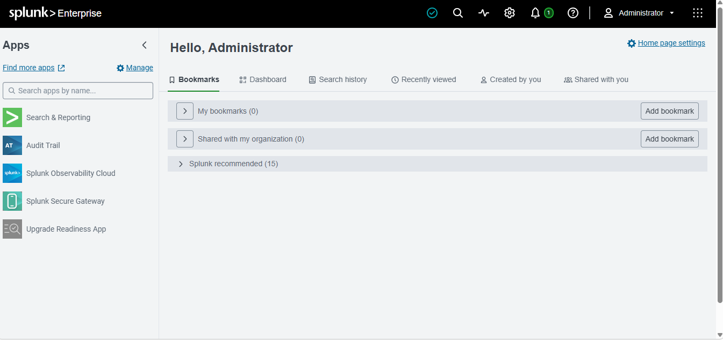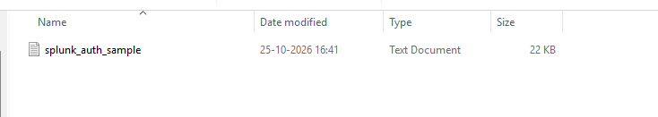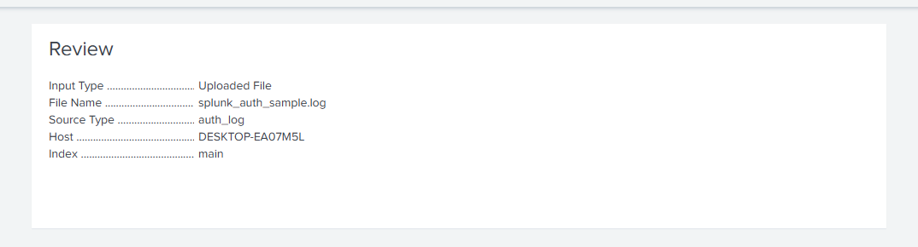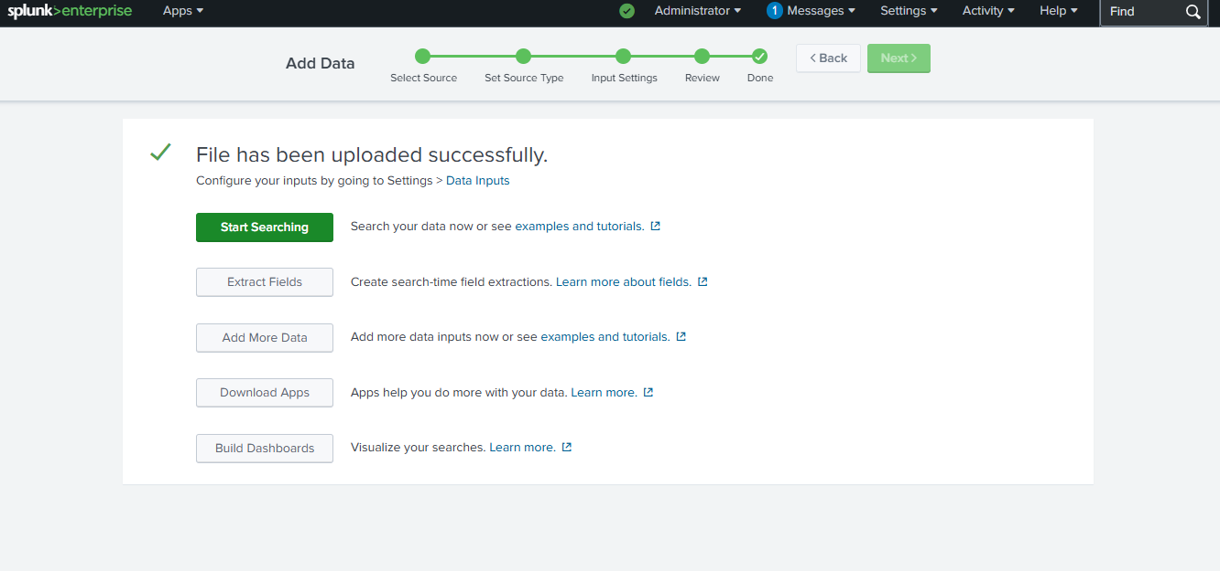
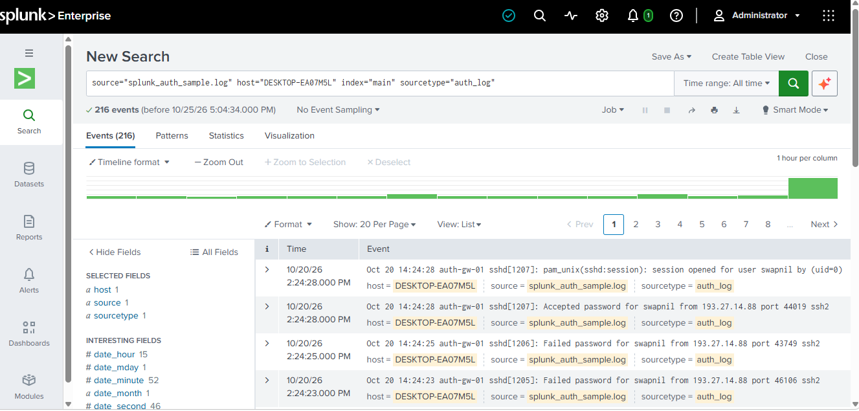
Search 1 - Isolatethe failed logins
so the command show us the failed login events . we see 86 failed attempts from our event file
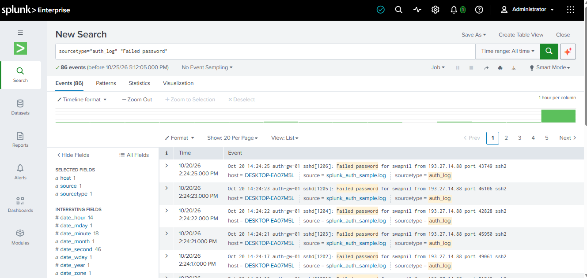
Search 2 — The money query: rank source IPs by failure count
So the commands show us the count of source ip ofrom which the failed login events were done. So using rex to group the ip address in the src_ip .we see that 193.27.14.88 had the maximum number of failed password attempts. Few ip like 77.21.6.140 ^ 84.112.33.9 aere the users genuily written the wrong password once or twice. But few atteampts were just a noise 3-4 failed attempts. So one source failing 64 times isn’t a human .its an automated bruteforce attack.
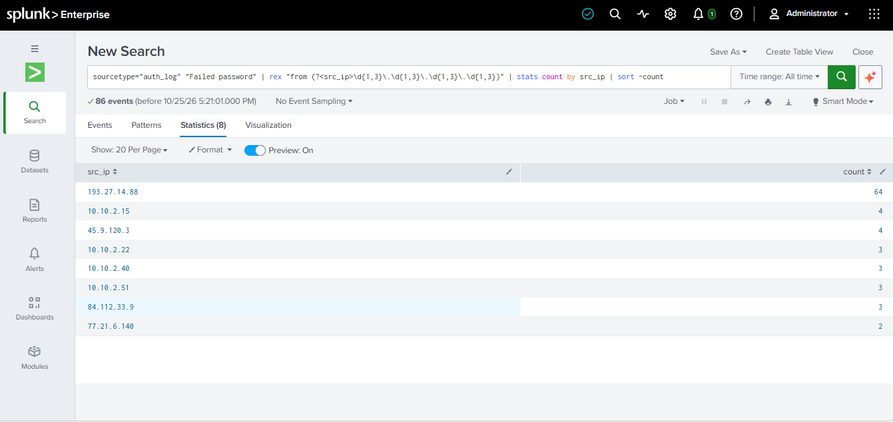

Search 3 — The pivot: did the attacker get in?
So the command show the failed and accepted password for Swapnil account and if the attacker really entered the Account . So at 10/20/26 at 2:24:28 pm the attacker got entered and the password got accepted for swapnil account from the IP193.17.14.88 this was the indicator of compromise. The first 64 failed login attempts then a succefull from the same IP is the exact pivot that’s turn noise into an incident.

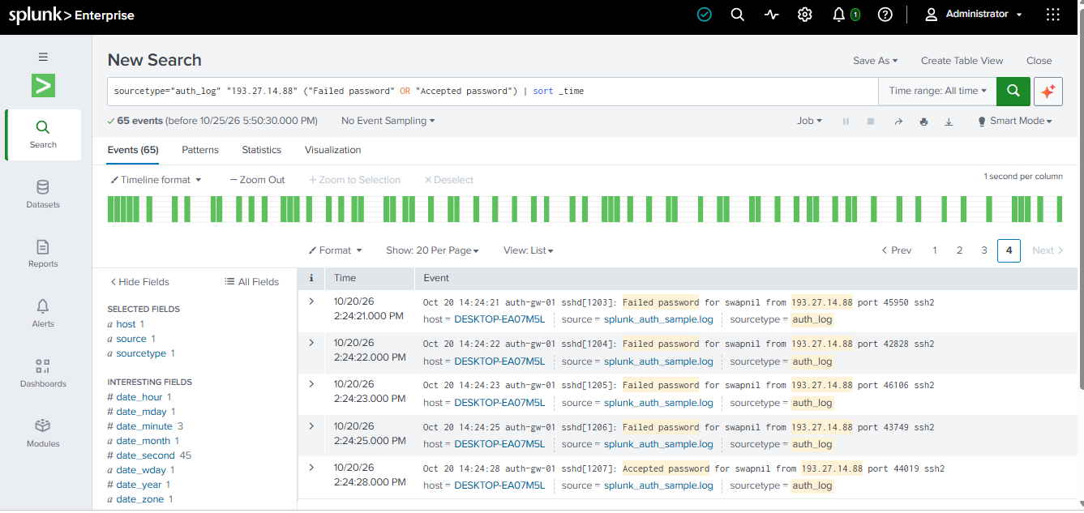

1. Visualize the attack — timechart
So visualization is important as it visualise the attack spike to have a greater view at event of comptromise .
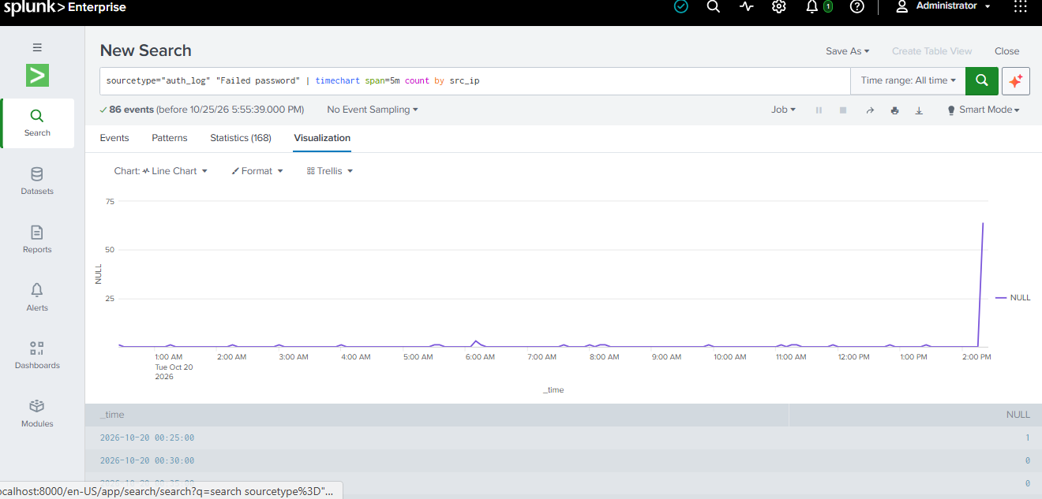
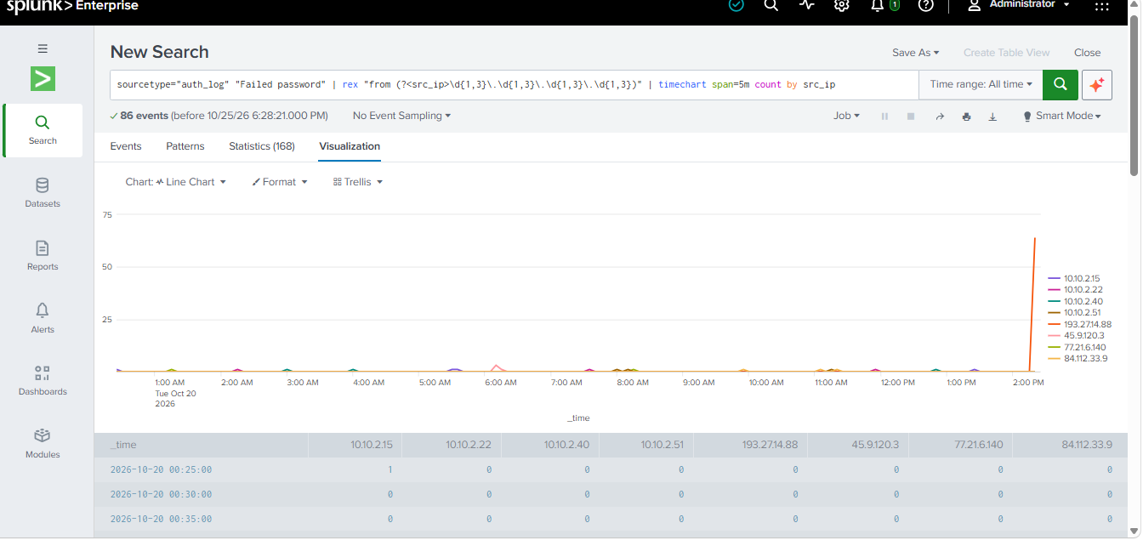
so here we can see a normal spike of failed password activities and the suddenly a big spike between 2:20 to 2:24 from the attacker ip 193.27.14.88 . this shows sudden spike and visulising the brute force made visible and good to investigate
Turn it into an alert — detection engineering
So here we crerate a custom filter of search . So when ever there are more than 20 failed password attempts which is our alert threshold it triggers a alert. As normal user never reach this.So we automated the process by creating a & saving a filter So everytime hunting by searching we basically save a command that alerts us automatically.
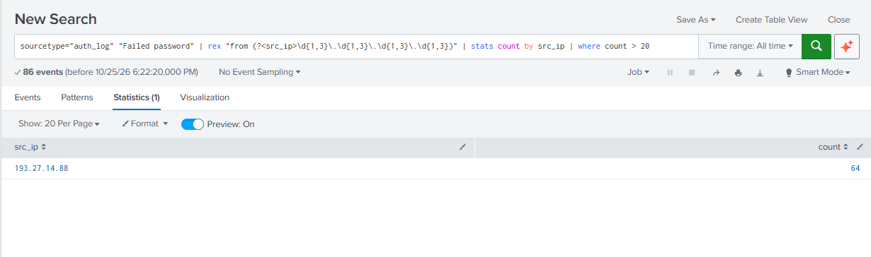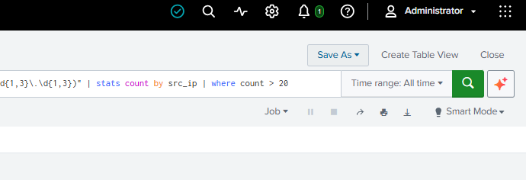

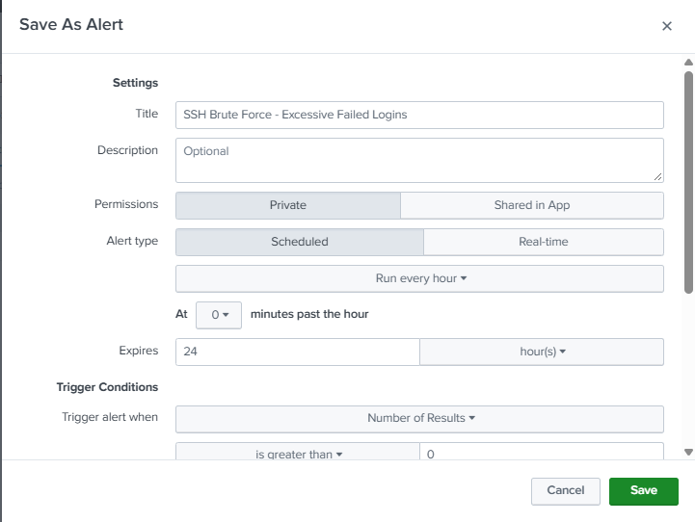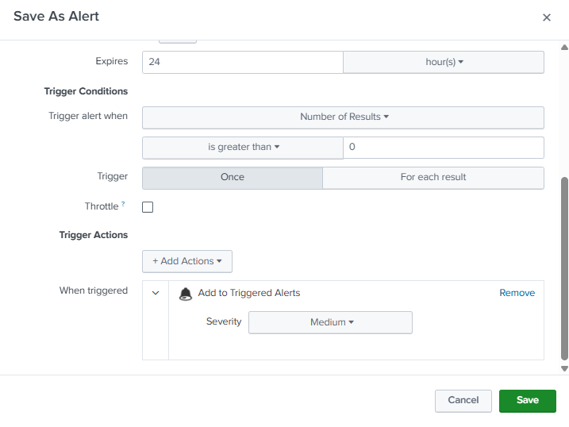
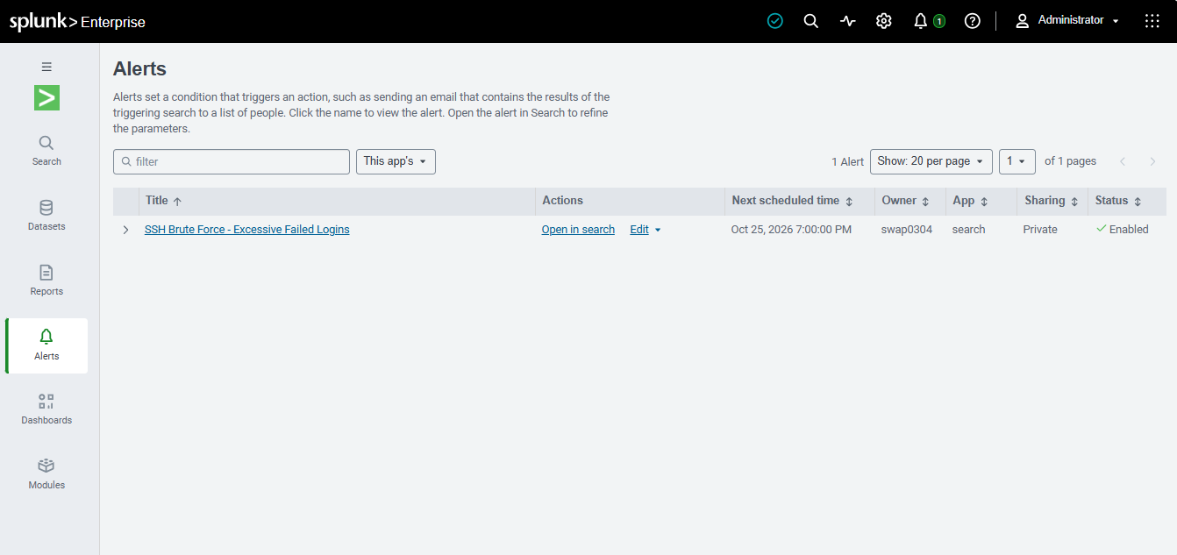
And

